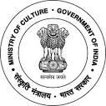
National Council of Science Museums
Ministry of Culture, Govt. of India
33, Block-GN, Sector- V, Salt Lake
Kolkata- 700091
Telephone- 033-2357-5545/9347/0850
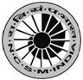
www.ncsm.gov.in
Notice Inviting E-Tender No. I-17012/25, dated 09/01/2023

E-Tender is invited for “For providing Upkeeping, Sanitary & Housekeeping Services at Regional Science Centre, Bhubaneswar Pandit Jawaharlal Nehru Marg, Bhubaneswar-751013,

Please visit website http://eprocure.gov.in/eprocure/app and search with Tender ID: 2023_NCSM_733915_1 for details & online tendering. Tenders may be submitted within 26/01/2023 upto 12.00 pm.

