
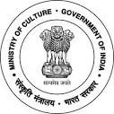
National Council of Science Museums
Ministry of Culture, Govt. of India
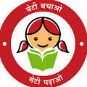
33, Block-GN, Sector- V, Salt Lake
Kolkata- 700091
Telephone- 033-2357-5545/9347/0850
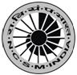
www.ncsm.gov.in
Notice Inviting E-Tender No. I-15014/86/Trans. Trees-SEC, Hyb/25-26

E-Tender is invited for “Transplantation of Trees at Science Experience Centre, CSIR-IICT Premises (Erstwhile NMDC Campus) Hyderabad” at an estimated cost of ₹28,55,565 /- (inclusive of LWC & GST)

Please visit website http://eprocure.gov.in/eprocure/app and search with Tender Id: 2025_NCSM_868394_1 for details & online tendering. Tenders may be submitted within 21.07.2025 (3.00 pm).

